**Phase 9: Reporting, Dashboards & Security Review**

**1. Reports (Tabular, Summary, Matrix, Joined)**

* Salesforce reports allow **analyzing and visualizing data** across objects.
* **Types & Use Cases:**
  + **Tabular:** Simple list of donations → used for donor mailing lists or campaign audits.
  + **Summary:** Group donations by Campaign → shows total amount raised per campaign.
  + **Matrix:** Donations by Donor vs Campaign → visualizes contribution patterns.
  + **Joined:** Combines multiple objects → e.g., Donor + Donation + Beneficiary for transparency reports.
* **Benefit:** Helps NGOs **track donation trends, monitor campaign performance, and ensure transparency to donors**.

**2. Report Types**

* Define **relationships between objects** for reporting purposes.
* **Use Case in CharityConnect:**
  + Custom Report Type: Donation → Campaign → Beneficiary → Donor.
  + Enables staff to generate **impact reports** showing exactly how donor contributions are allocated.
* **Benefit:** Provides **flexible reporting options** for internal audits and donor updates.

**3. Dashboards**

* Visual representation of key metrics using **charts, tables, and gauges**.
* **Use Case:**
  + Campaign Progress Dashboard: Total amount raised vs goal, active campaigns, top donors.
  + Donor Engagement Dashboard: Loyalty points, badges earned, recurring donations.
* **Benefit:** Allows NGO staff to **monitor real-time performance** and make informed decisions.

**4. Dynamic Dashboards**

* Dashboards display **data personalized to the logged-in user**.
* **Use Case:**
  + Donor Portal: Donors see **only their own contributions and badges**.
  + NGO Manager: Sees **all campaigns, donations, and beneficiary details**.
* **Benefit:** Ensures **data privacy** while providing tailored insights.

**5. Sharing Settings**

* Control **who can see or edit records** in Salesforce.
* **Use Case:**
  + Donations: Private by default → only donor & NGO Staff can view.
  + Campaigns: Public Read-Only for all NGO staff → allows transparency without risk of modification.
* **Benefit:** Protects sensitive donor data while enabling collaboration among staff.

**6. Field Level Security (FLS)**

* Controls visibility and edit access to specific fields for different profiles.
* **Use Case:**
  + Donor email & payment information → visible to NGO Staff, hidden from Donor Users.
  + Loyalty Points & Badge Status → visible to both staff and donor portal.
* **Benefit:** Ensures **data confidentiality and regulatory compliance**.

**7. Session Settings**

* Configure **session timeouts, login history, and security policies**.
* **Use Case:**
  + Donor portal session timeout set to 30 minutes of inactivity.
  + Staff portal session timeout: 1 hour with automatic logout.
* **Benefit:** Enhances **data security**, reduces risk of unauthorized access.

**8. Login IP Ranges**

Restricts access to Salesforce org to **specific IP addresses**.

* **Use Case:**
  + NGO staff can log in only from office or verified home IP addresses.
* **Benefit:** Adds **network-level security** to prevent unauthorized logins.

**9. Audit Trail**

* Tracks all **configuration changes and system modifications** in Salesforce.
* **Use Case:**
  + Track updates to Campaigns, Donations, or Beneficiary records.
  + Identify who modified a donor record and when.
* **Benefit:** Provides **accountability, transparency, and compliance** for NGO reporting.

**Screenshots:**

**Custom report types**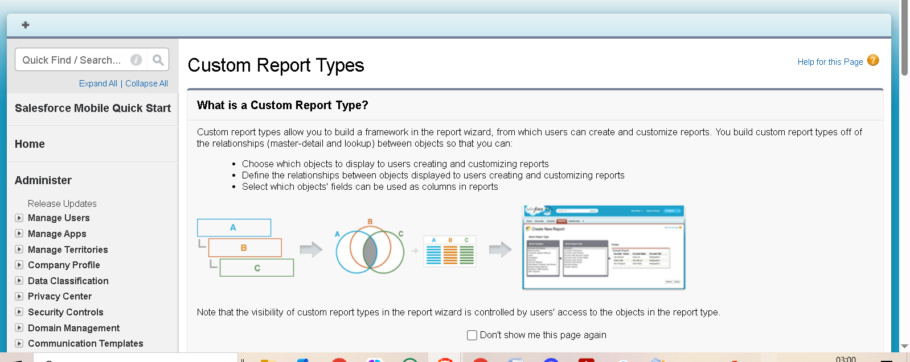 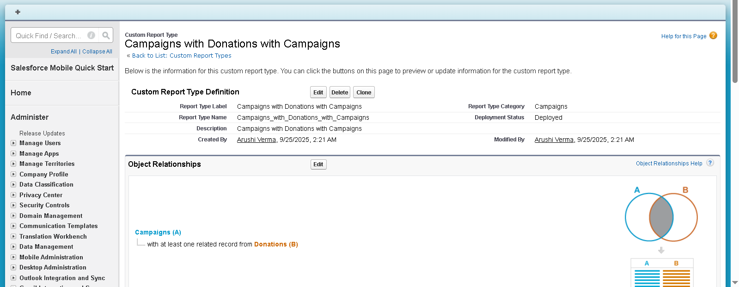

**Sharing settings**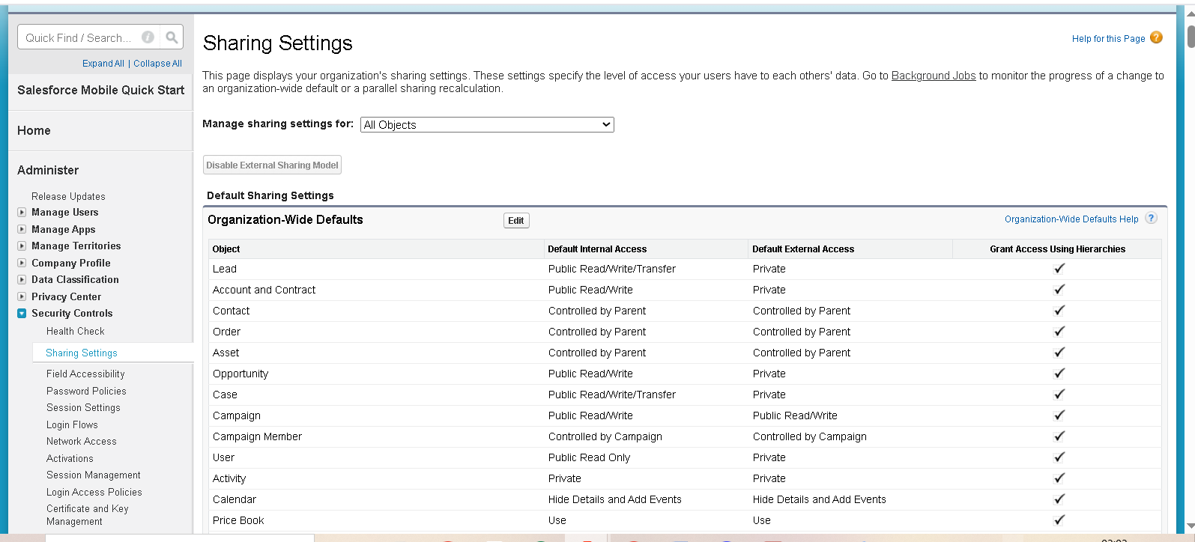

**Login history** 